PHP Tutorial – inserting database records via a web interface

In this tutorial we are going to look at how to use a web form and a php script to allow the user to insert new records into a database table via a web interface. Before doing this tutorial you should have done the newnumyspace, forms, and the previous PHP tutorials.

In the following exercises remember that you will then need to upload copies of each file you create onto your web space on the newnumyspace web server and that to test them you need to enter the appropriate web address into the address bar of your web browser.

Exercise 1: Creating the database table that we will need

The first thing that we need to do is import a .sql file that has already been created for you into phpMyAdmin that contains code to create database tables called fine_feedback and fine_location. We will use the fine_feedback table in exercise 2 to store customer feedback for a fictional restaurant (‘Fine restaurant’), but won’t use the fine_location one until the directed learning section.

- From the E-learning portal (Blackboard) download the file fineRestaurant.sql and save it to your u drive
- Import the sql file using the phpMyAdmin interface (refer back to PHP tutorial 4 if you can’t remember how to do this). This will create tables called ‘fine_feedback’ and ‘fine_location’ in your newnumyspace MySQL database.
- Use phpMyAdmin to view the structure of the fine_feedback table. You will see that it contains fields for customer feedback records.
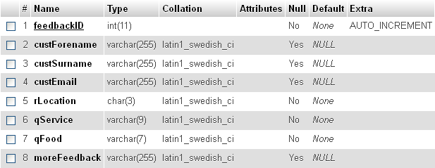

Exercise 2: adding a new record to our database table

In this exercise you will create a web page that contains a web form that allows the user to enter feedback about a fictional restaurant (‘Fine restaurant’) and a
PHP script to insert a new record into the ‘fine_feedback’ table using the feedback details entered via the form.

- Enter/copy the HTML code given below into a new HTML5 web page (remembering to use the basic HTML core tags as a basis first) and save it as restaurantFeedbackForm.html. It will contain a form that will allow the user to:
- Enter their forename, surname and the restaurant location
- Provide feedback on the quality of service and the quality of the food
- Provide any general comments that they have
- Click a submit button with the label “Submit feedback”.

<h1>Fine restaurant feedback</h1>
<p>Please provide feedback on your experience at our restuarant</p>
<form id="feedback" action="addFeedback.php" method="get">
<div>Forename: <input type="text" name="custForename"></div>
<div>Surname: <input type="text" name="custSurname"></div>
<div>Email: <input type="text" name="custEmail"></div>
<div>
Location of restaurant:
<select name="rLocation">
<option value="ncl">Newcastle</option>
<option value="sun">Sunderland</option>
<option value="nyc">New York</option>
<option value="par">Paris</option>
<option value="rom">Rome</option>
</select>
</div>
<div>
Quality of service:
Excellent <input type="radio" name="qService" value="excellent">
Good <input type="radio" name="qService" value="good">
Average <input type="radio" name="qService" value="average">
Poor <input type="radio" name="qService" value="poor">
</div>
<div>
Quality of food:
Excellent <input type="radio" name="qFood" value="excellent">
Good <input type="radio" name="qFood" value="good">
Average <input type="radio" name="qFood" value="average">
Poor <input type="radio" name="qFood" value="poor">
</div>
<div>
Please provide any other feedback that you feel is
relevant: <br>
<textarea name="moreFeedback"
style="width:500px; height:120px;"></textarea>
</div>
<div><input type="submit" value="Send feedback"></div>
</form>

When viewed in a web browser it should look something like this:
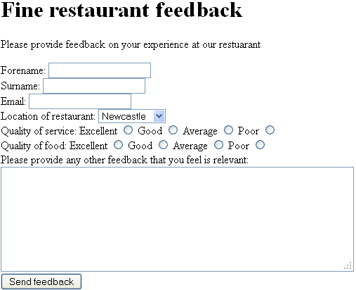

Please note that the html provided has been kept deliberately basic for the purposes of clarity. It does not, for example, contain accessibility features (like field sets, legends, labels and access keys). Also, the form has a basic layout and uses div and br tags for spacing rather than using CSS to style the layout and other features of the form using the method covered earlier in the module. You should add accessibility features yourself and improve the styling (and make any other changes that you think may be required) of course after the workshop.

- Create a PHP script called addFeedback.php (remembering to use the basic HTML5 core tags as a basis) that will insert a new feedback record into the fine_feedback table of your MySQL database using the data entered into the web form. It should:

- Connect to the database
- Extract the data sent by the form which is in the Request stream
- Use that data to insert a new record into the fine_feedback database table putting the user’s forename, surname and email, and the restaurant location, the quality of service and quality of food ratings and the other feedback details from the web form into the corresponding fields (custForename, custSurname, custEmail, rLocation, qService, qFood, and moreFeedback) of the new record

(NOTE: you don’t need to enter a new feedbackID for the new record as this field in the database is of type Auto Increment and therefore a value will automatically be entered by the database)

- Output a message to the web browser to indicate that the new record has been added to the database. Perhaps it should also give details of the record that was added.
- Use the web form to submit some feedback and then check whether the new feedback record was added using the phpMyAdmin web interface

Challenge - handling undefined index errors, mandatory fields, optional fields and special characters

As we saw in an earlier PHP tutorial, we need to handle the situation where request stream data has not been sent to the server to prevent undefined index errors. We also saw how to display a message saying that a mandatory form field had not been completed.

- Make sure that you have added code in your PHP script to prevent undefined index errors. Hint: use isset()
- Modify the PHP code so that it either displays the ‘Quality of service’ rating if the user selected one or otherwise displays a message prompting the user to provide feedback on this. Do the same for the ‘Quality of food’ rating. Hint: use empty()

In a real feedback system, you may in some situations want to give the user the choice of entering their personal details (e.g. forename, surname and email) or not. You may also want to give the user the choice of adding any other feedback or not as well.

- Modify the form to add words to show that entering a forename, surname, email address and other feedback is optional
- Modify the PHP script so that it only tries to display a forename if one has been entered by the user. Hint: use empty()
- Do the same for surname, email and other feedback.

In a real system, the user may enter characters that have special meaning in SQL, such as an apostrophe, which can cause problems when trying to add a record to a database. For example, they may enter O’Connor in the surname field of the form. One way to prevent such problems is to escape any such characters before we try to insert a record into the database.

- Modify the PHP script so that it escapes any special characters that may have been entered in the surname. Hint: use real_escape_string()
- Do the same for forename, email and other feedback

Extra challenge – try to modify the PHP code so that a new database record is only inserted if a ‘Quality of service’ rating and a Quality of food’ were provided.

Directed learning – generating values for the user to choose from

If you have time in the workshop attempt this challenge, otherwise attempt it as directed learning. For this challenge you will modify the web form created in exercise 2 so that the user can choose the restaurant location from a select list, but this time it will be a dynamic list created from data in the database.

- Re-save restaurantFeedbackForm.html as restaurantFeedbackForm.php. This will allow us to include php
- Modify the part of the html in the form that lets the user select the location of the restaurant by removing the option elements so that it is as shown below

<div>
Location of restaurant:
<select name="locationID">

</select>
</div>

- In between the opening and closing select tags for location add php code that will dynamically generate the option choices for the select list for location using the location records from the ‘fine_location’ database table retrieved through a database query – one option per location. The user will then be able to select an option (a location). For reference the structure and records of the fine_location table are as follows:

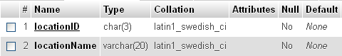
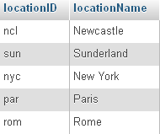

Hints:
- In pseudo code I would:
- connect to the database
- assign a query which will retrieve all locations from the location table to a variable.
(the query would be: “SELECT locationID, locationName FROM fine_location”)
- execute that query to retrieve a result set, stored into a variable.
- loop through the result set, and for each iteration (row returned by the query) echo one set of <option></option> tags using the locationID field value the value attribute and as the locationName as the text to display to the user. Each set of tags should look something like the following:
<option value="ncl">Newcastle</option>

